**RABBIT & CAVY ENTRY FORM**

**Kindly Sponsored By**

**Ardenlea Feather & Fur Feed**

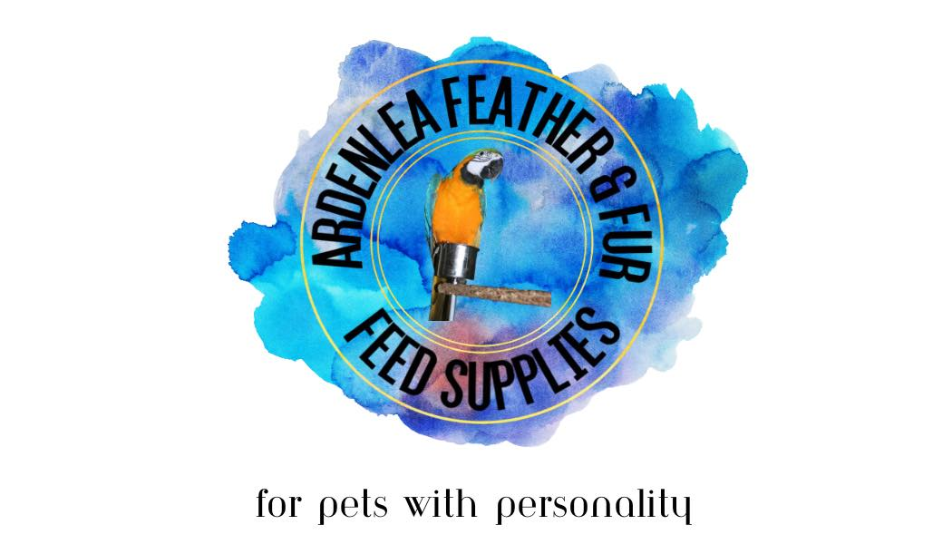

**Saturday 5th August, 2023**

**Prize Money: 1st £5.00 2nd £4.00 3rd £3.00**

**Rabbits**

Any Variety Fancy

Any Variety Fur

Any Variety Lop

Any Variety Rex

Pet rabbit owned by adult ( 16+?)

Pet rabbit owned by child  (under 16)

**GRAND CHALLENGE**

**Cavies**

AV - Self

AV - Abyssinian / Coated

AV - Marked / Ticked / Coated

AV - Crested / Emerging

Pet Guinea Pig owned by adult (16+)

Pet Guinea Pig owned by Child (under 16)

**GRAND CHALLENGE**

**Entries closing date: 14th July, 2023**

|  |  |  |  |
| --- | --- | --- | --- |
| **Name** |  | | |
| **Address** |  | **Post Code** |  |
| **Email** |  | **Telephone** |  |

|  |  |  |  |
| --- | --- | --- | --- |
| **Class Name** | **Number of Entries per Class** | | **Cost per entry £1.00** |
|  |  | |  |
|  |  | |  |
|  |  | |  |
|  |  | |  |
|  |  | |  |
|  |  | |  |
|  |  | |  |
|  |  | |  |
|  |  | |  |
| Payment can be made by **BACS** to Keith Show, Account No 00115993 Sort Code 82-65-24 – please use name as a reference.  Please make cheques payable to Keith Show. *Any cheques returned by our Bank as unpaid will incur an additional charge of £20 to cover administrative costs.* | |  |  |
| **TOTAL** |  |

### Please send your completed form and remittance to

### Carly Mackay Email:info@keithshow.org.uk

**PLEASE NOTE**

All numbers, membership badges and other relevant details can either be collected from the show office or will be sent to you approx.10 days before the show commences.

By signing, completing, and returning this form I am agreeing to my details being used for inclusion in the Show Catalogue and to be contacted by Keith Country Show in connection with future events.

SIGNED: _________________________________ DATE: __________